**Tasks : 10/27/2017 Due 6.00 PM CST on 10/27/2017**

**AWS :**

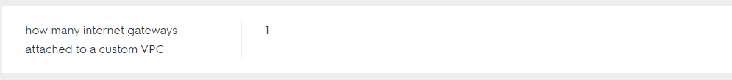

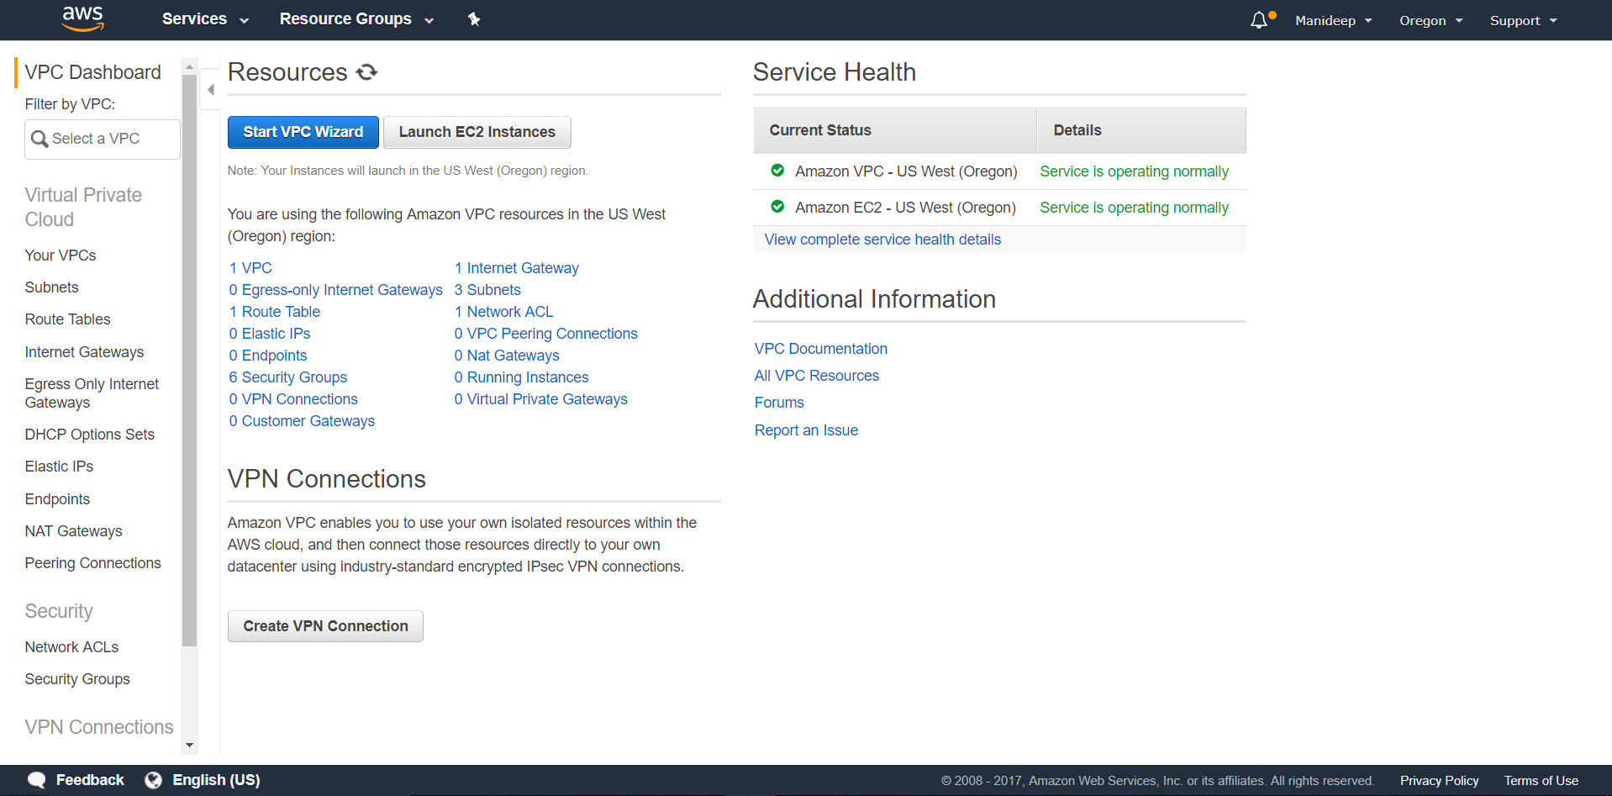

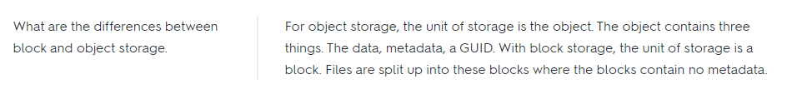

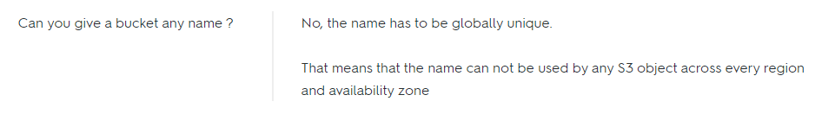





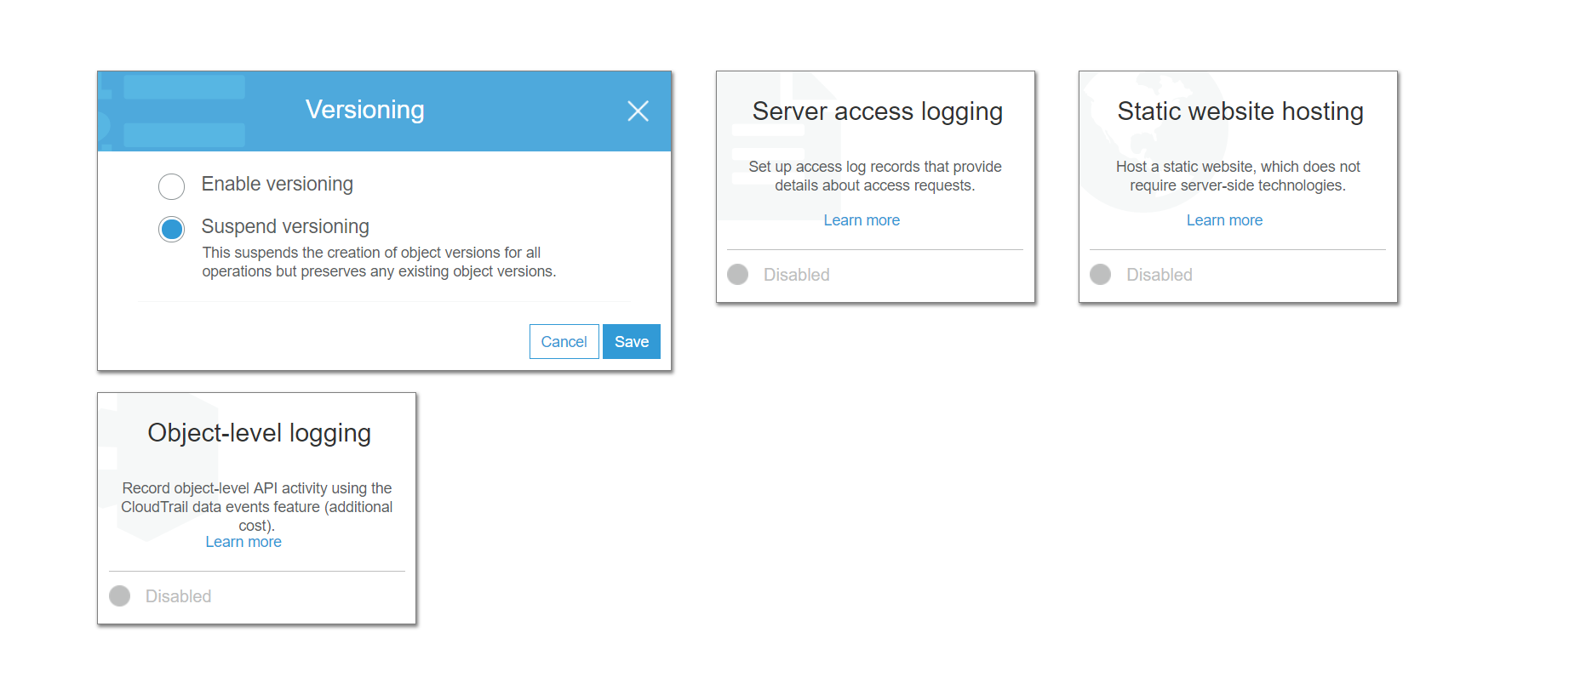

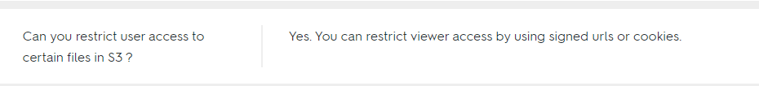

**Spring**

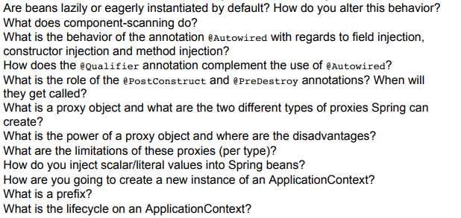

**Java 8**

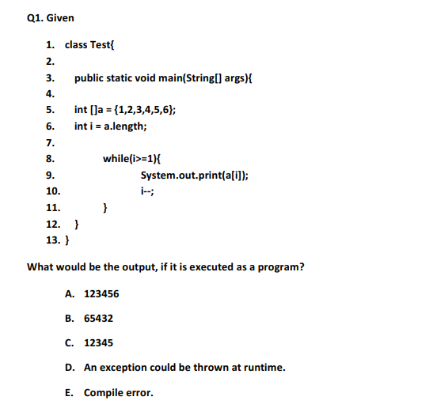

1. Arrayindexoutofbonds exception

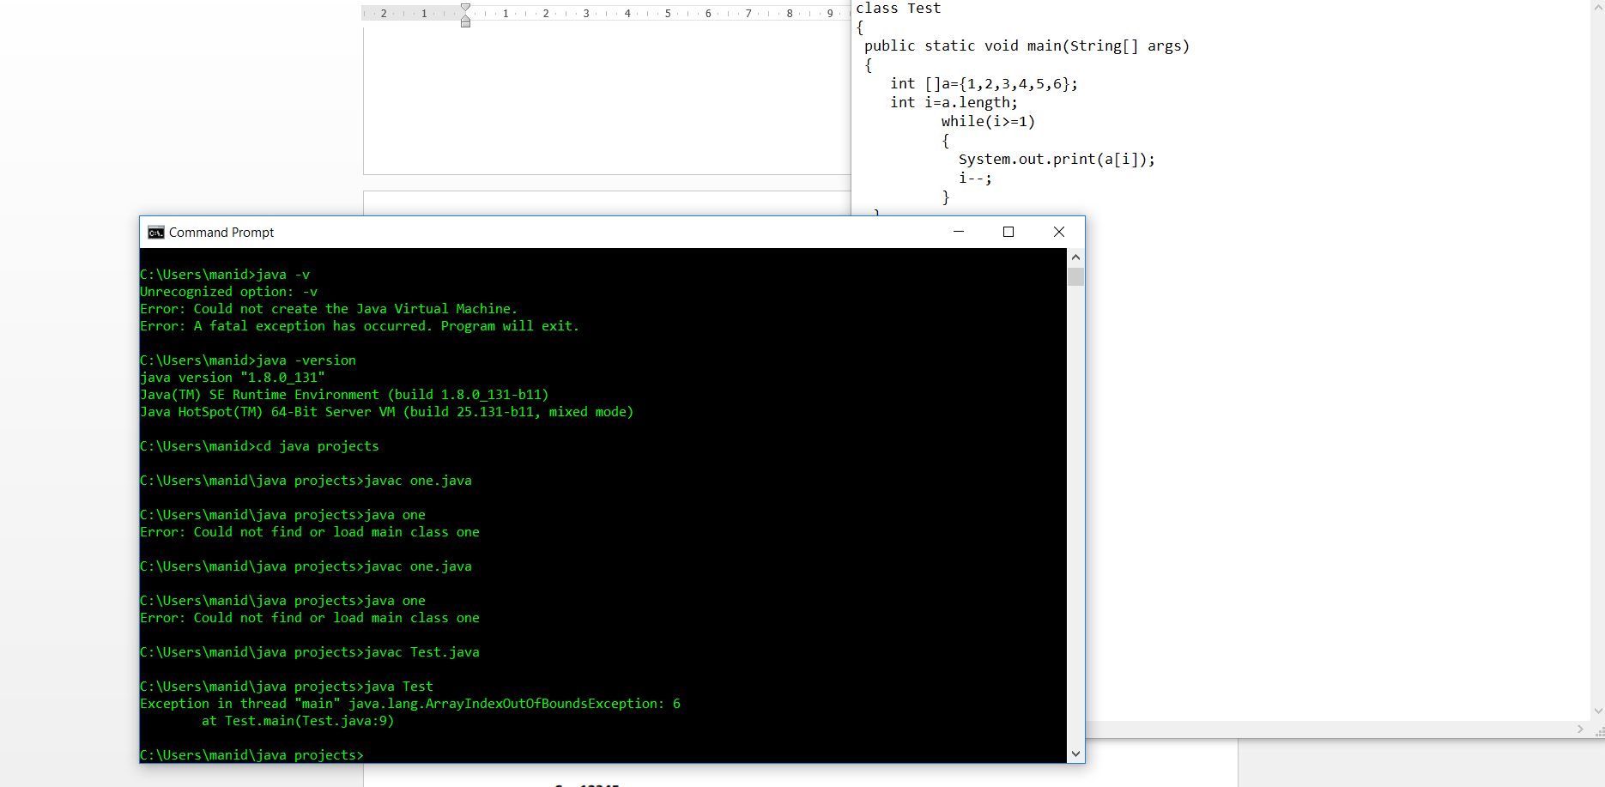

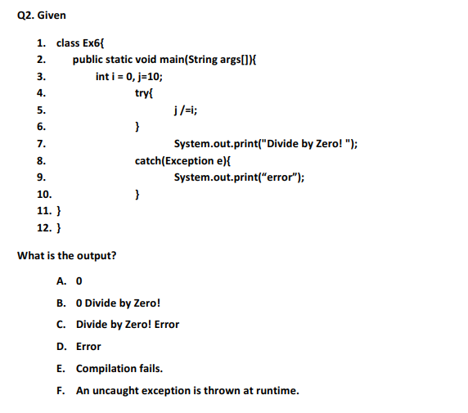

1. E. Compilation fails

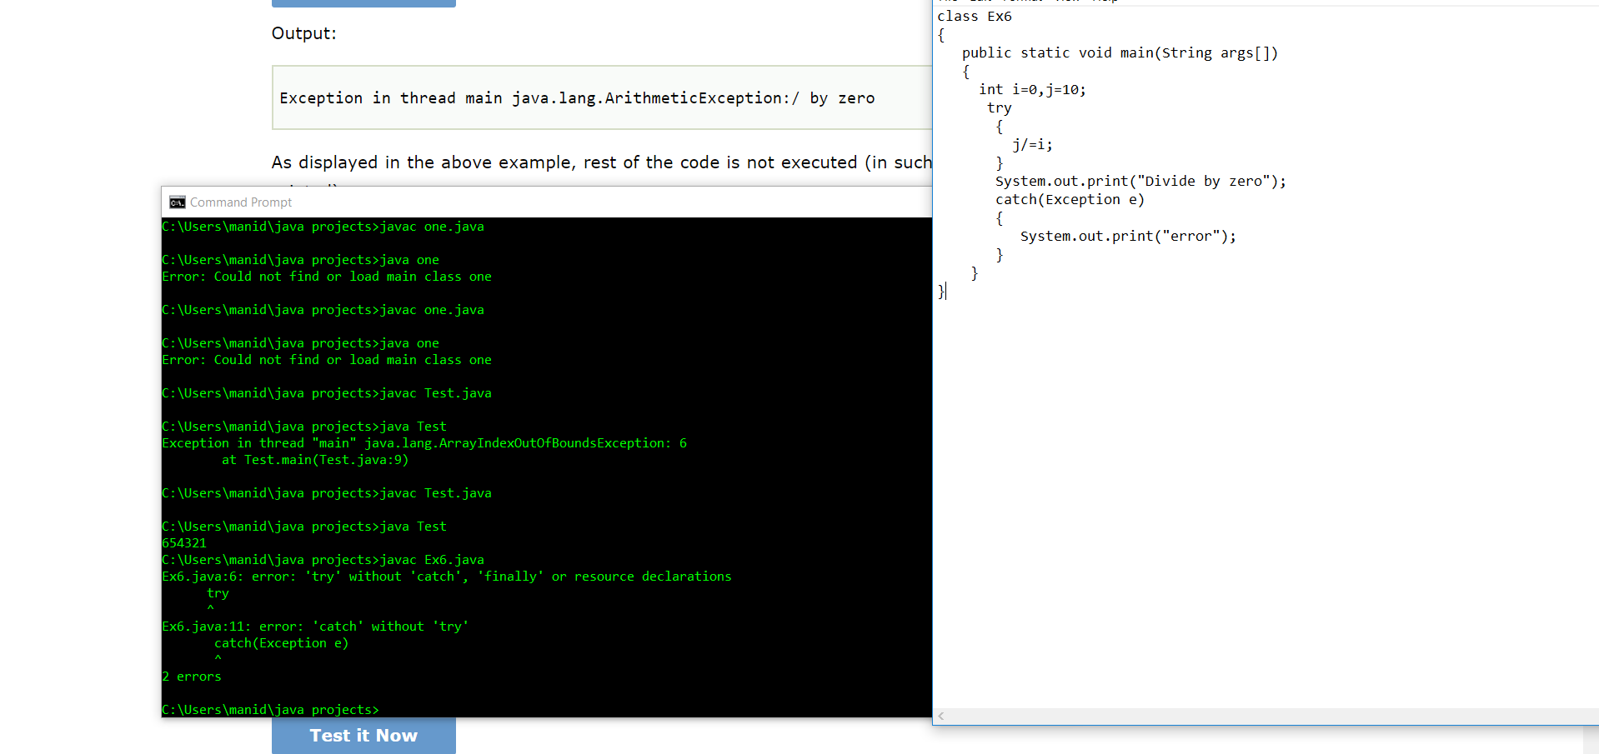

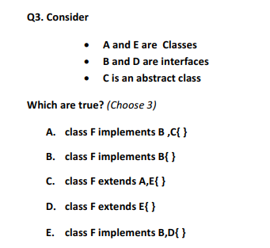

1. B,D,E

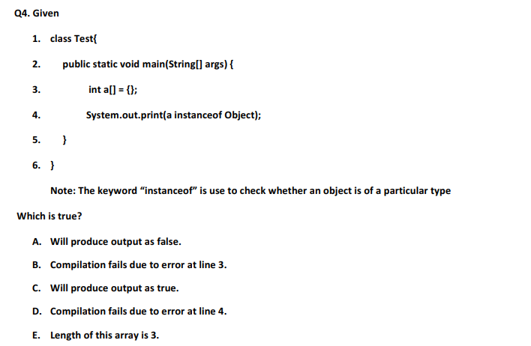

1. C. Will produce output as true.

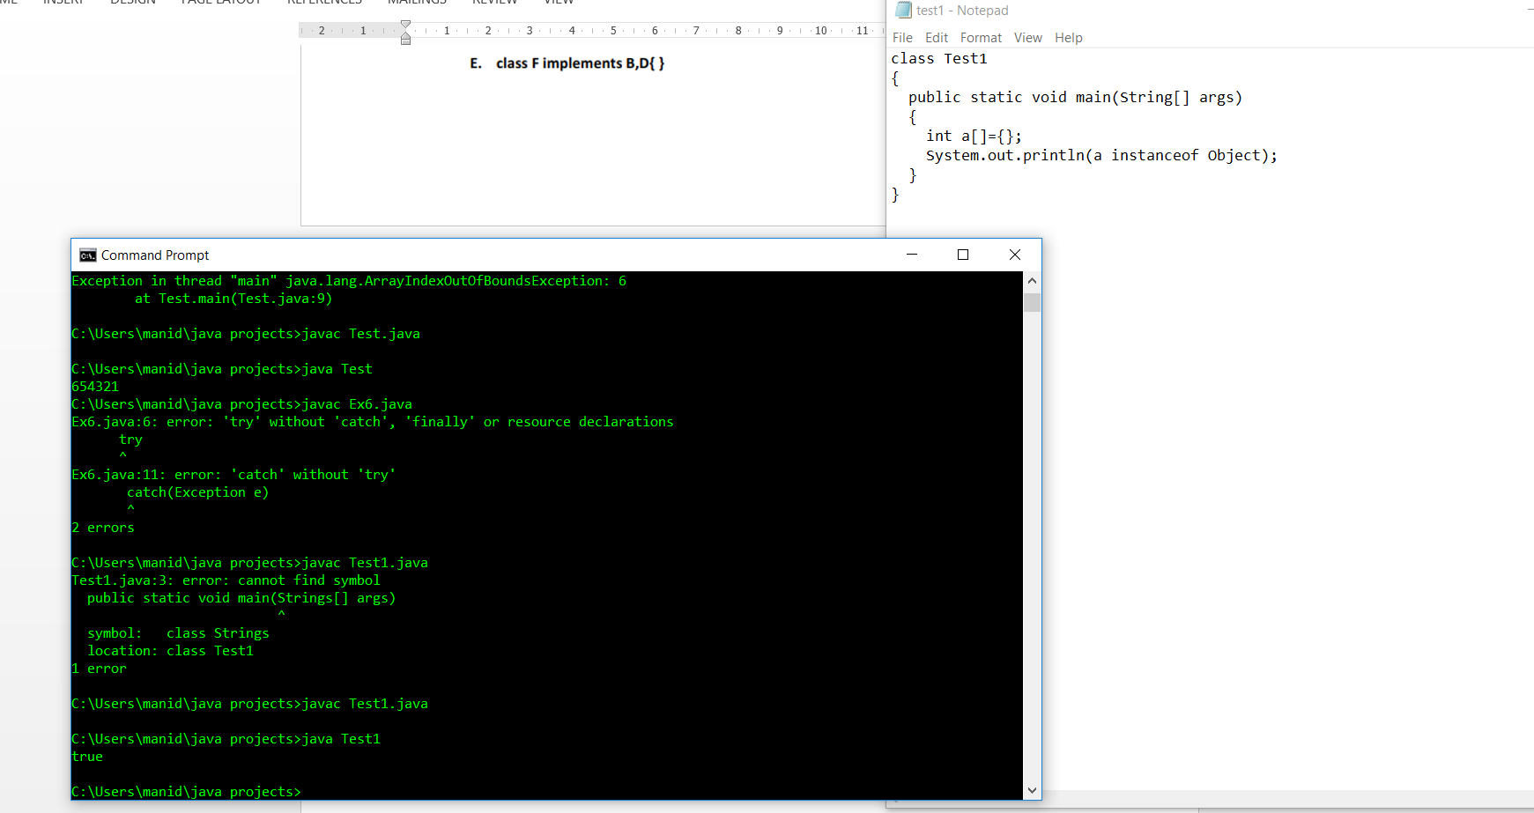

**Angular 4**

**Integrate Angular 4 with Spring Boot WebApp and SpringToolSuite**

**Database**

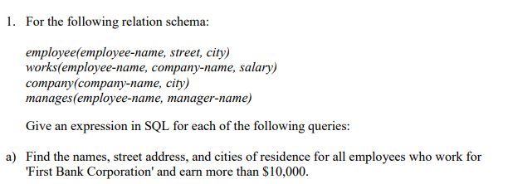

select e.employeeName, e.street, e.city from

employee e, works w where e.employeeName=w.employeeName and (companyName = 'First Bank Corporation' and salary > 10000);

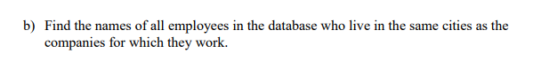

select e.employeeName from employee e, company c, works w where e.city=c.city and w.companyName=c.companyName and w.employeeName=e.employeeName;



Manager table has no details about manager street or city.